SUPERMARKET SALES SQL QUERIES

* KPI

1. The total Customers the data have

Select count(distinct Invoice_ID) as total_customers

from supermarket_sales_dup

;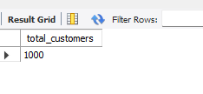

1. How many unique Cities, Branch does the data have?

Select

distinct city, branch from

supermarket_sales_dup;

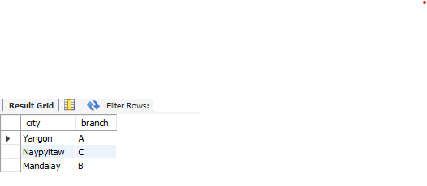

1. How many unique Customer type does the data have?

Select

distinct customer_type

from

supermarket_sales_dup;

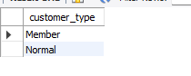

1. How many unique Product line does the data have

Select distinct Product_line

from

supermarket_sales_dup;

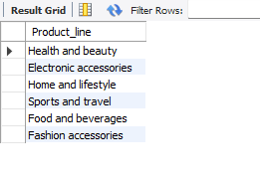

1. What is the most common payment method?

SELECT DISTINCT payment,

COUNT(*) AS common_method

FROM supermarket_sales_dup

GROUP BY payment

ORDER BY common_method DESC;

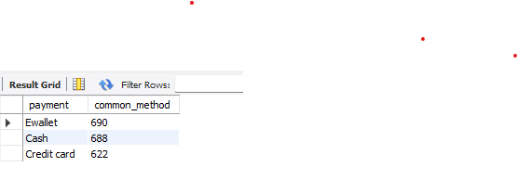

* Business Key Problems and Answers
* What is the most selling product line

SELECT DISTINCT Product_line, sum(Quantity) AS Highest_product

FROM supermarket_sales_dup

GROUP BY Product_line

ORDER BY Highest_product DESC;

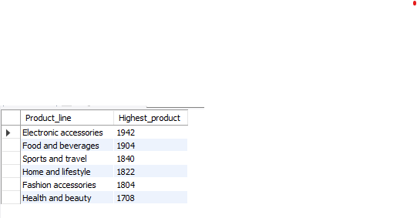

* What product line had the largest revenue

SELECT DISTINCT

Product_line, round(Sum(Total),2) AS ranked_revenue_generated

FROM

supermarket_sales_dup

GROUP BY Product_line

ORDER BY ranked_revenue_generated DESC;

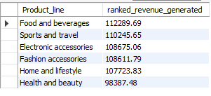

* What is the total transactions made by each gender in each product line

Select Product_line, gender,

count(*) AS total_transaction

FROM supermarket_sales_dup

GROUP BY Product_line,gender

ORDER BY 1;

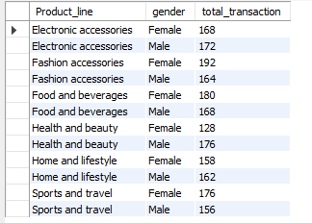

* Find the top 5 customers with the highest total sale

Select invoice_id ,

sum(total) as Highest_purshase

from supermarket_sales_dup

group by invoice_id , total

order by Highest_purshase desc

limit 5;

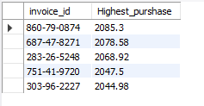

* Find the distinct customers who purchased from each product line

Select distinct Product_line,

count(Invoice_ID)as Num_Purchased

from supermarket_sales_dup

group by Product_line

order by Num_Purchased;

